Name: ______________________________________ | Date: ___________________

Blank Grid Models

Force acting on cart = | Δt = | Force acting on cart = | Δt = | Force acting on cart = | Δt =
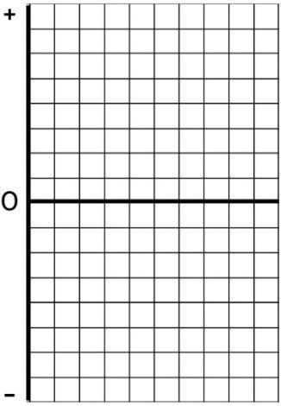  Area = |  |   Area = |  |   Area =

Force acting on cart = | Δt = | Force acting on cart = | Δt = | Force acting on cart = | Δt =
  Area = |  |   Area = |  |   Area =

Condition tested:
Mass of cart = V1 = V2 = | ΔV = | Force acting on cart = | Δt =
  Area = |  |   Area =

Condition tested:
Mass of cart = V1 = V2 = | ΔV = | Force acting on cart = | Δt =
  Area = |  |   Area =

